Creating a Billing Alarms

Cloud Provider : AWS

Difficulty : Beginner

Objectives :

* Create a billing alarm for R500($85)

Step One – Enable monitoring of billing alerts

For the billing information to be collected and used to create the alarms we need to ensure that the monitoring has been enabled

To enable the monitoring of estimated charges do the following :

* Open the AWS Billing and Cost Management console at <https://console.aws.amazon.com/costmanagement/>.

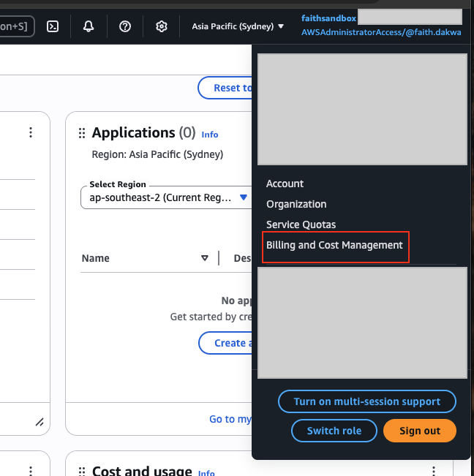

* In the navigation pane, choose Billing Preferences.

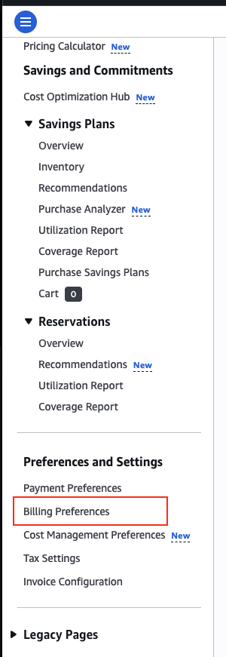

* By Alert preferences choose Edit.

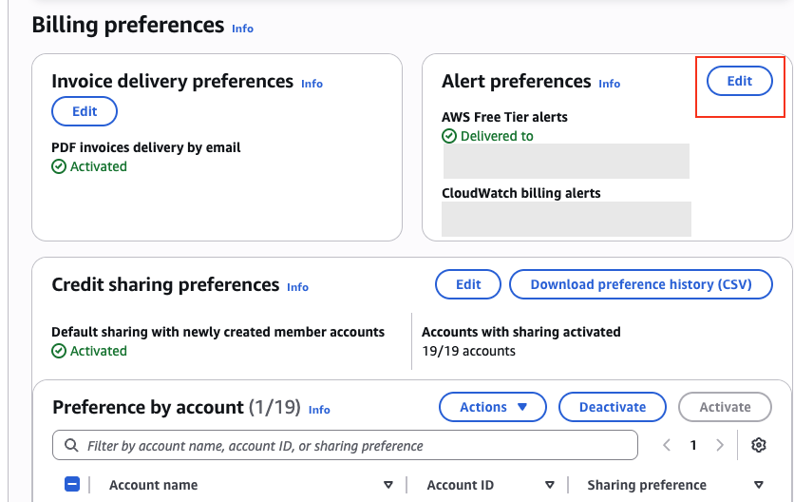

* Choose Receive CloudWatch Billing Alerts.

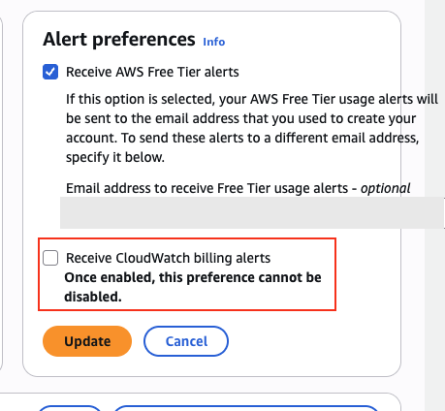

Choose Save preferences.

Step Two – Create Billing Alarm

Ensure region is set to us-east-1. Billing Metric data is stored in that region and represents worldwide charges.

* -Create a billing alarm

Open the CloudWatch console at <https://console.aws.amazon.com/cloudwatch/>.

In the Overview landing page **→** choose create alarms, in the alarms landing page **→** choose create alarm.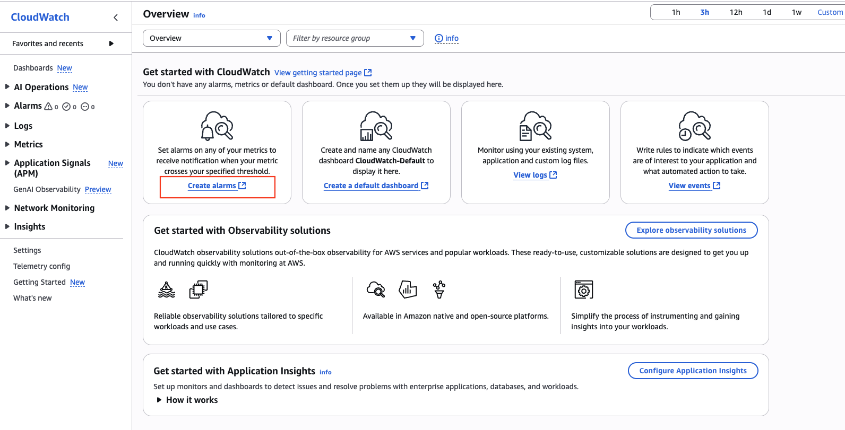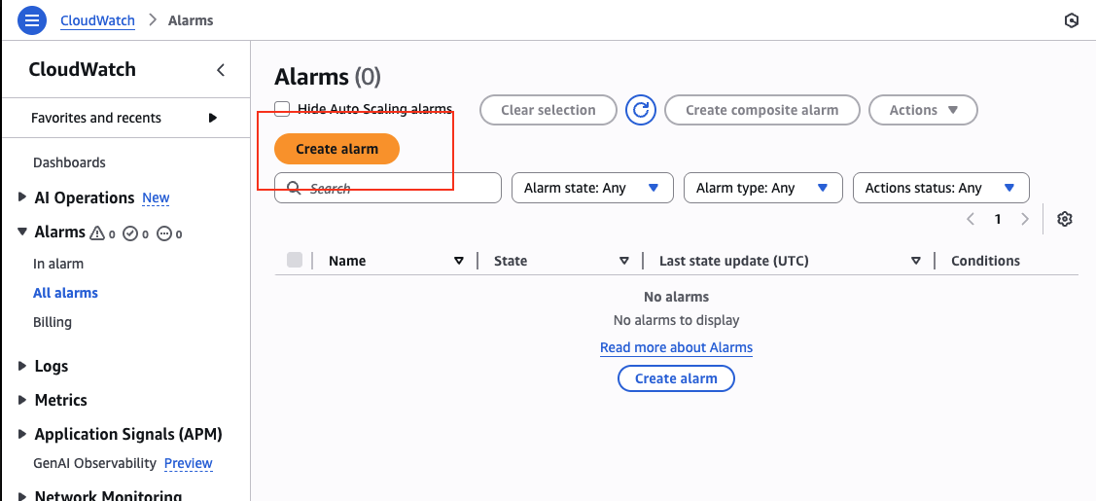

-Select metric

Select metric **→** choose Billing **→** choose Total Estimated Charge.

Note- if you don't see the Billing /Total estimated charge metric its likely due to billing alerts not being enabled and region not being changed to us-east-1

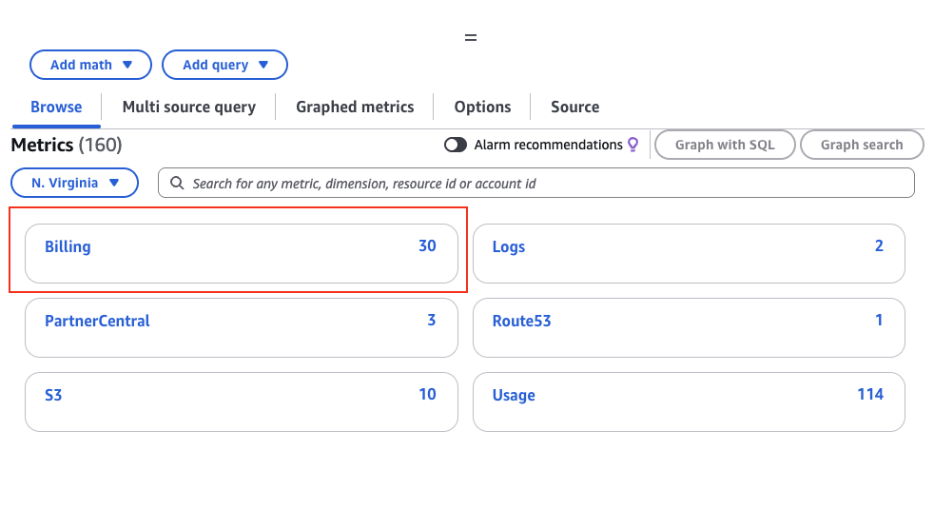

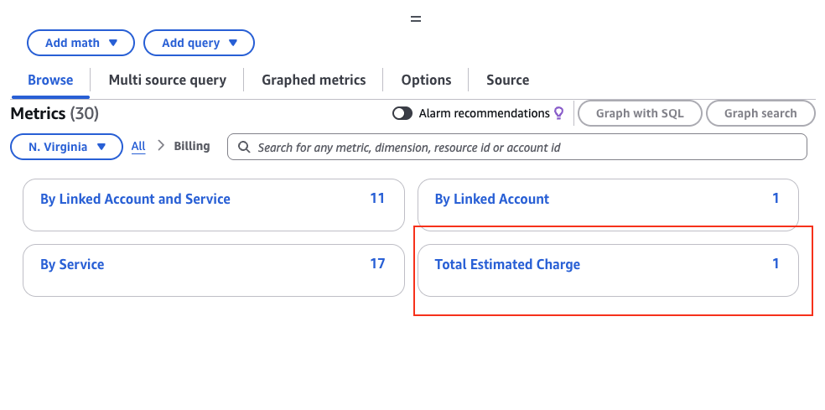

Note - You can filter by **Linked Account**, **Service**, or **Currency**.

* **Define Threshold**

Set **Threshold type** and enter your preferred currency.

Click **Next**.

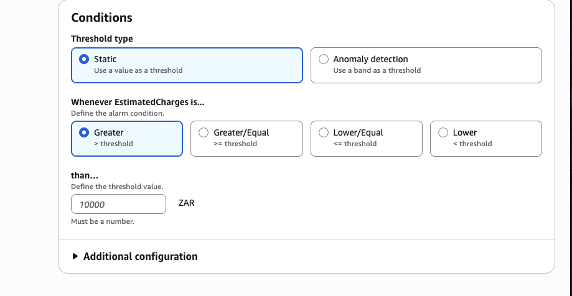

* **Set Notification**

Choose **Create new topic** or select an existing **SNS topic** to receive notifications (email, SMS, etc.).

Add your email and confirm subscription in your inbox.

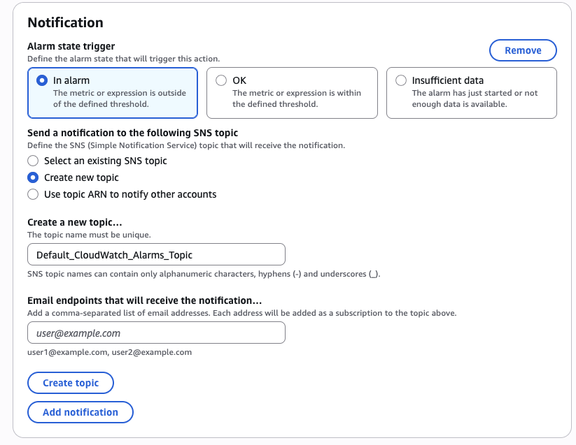

* **Name the Alarm**

Give it a descriptive name

**Create Alarm**

Click **Create Alarm**.

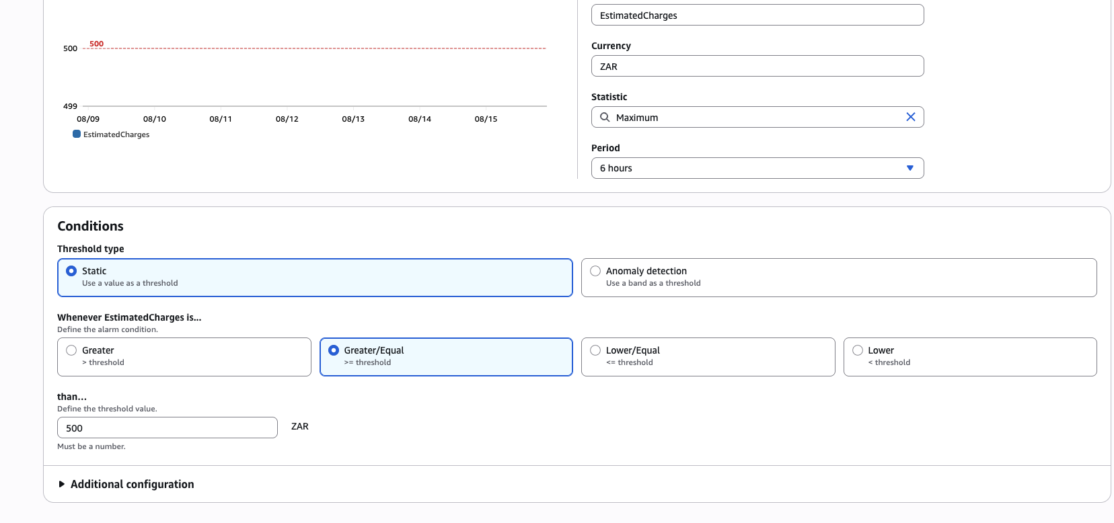

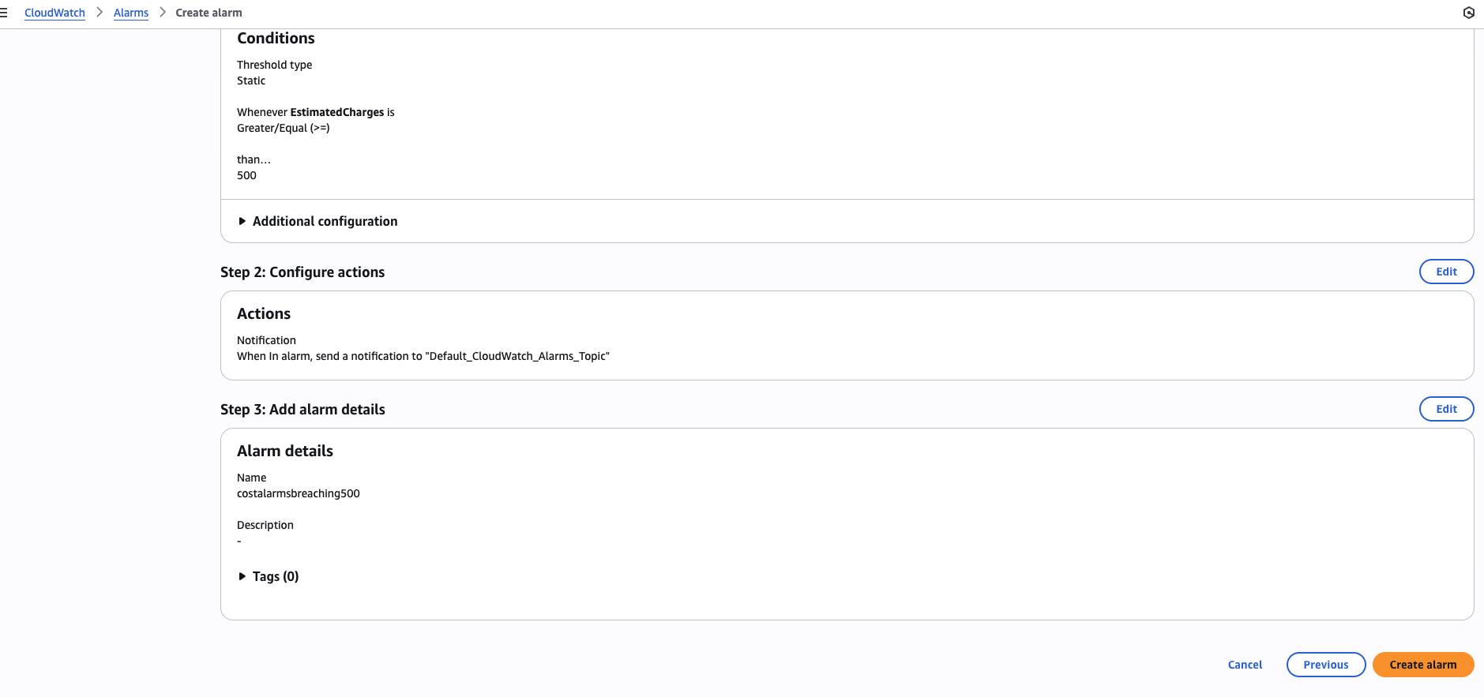

* CloudWatch will now monitor your billing and alert you when costs exceed the threshold.

